Software Testing Report

Victoria State Accident
Ben White - s2850345
Liam Preston - s5301986
Thomas Chapman - s5251549

Table of Contents
1.0 Unit Tests 3
2.0 Coverage Report 4
3.0 Requirements Acceptance Testing 5

Unit Tests

No | Test Case | Expected Results | Actual Results
1.0 | Loading Data from Dataset (General Loading) - df = pd.read_csv()
1.1 | Loaded data from a valid file path. | Data is successfully loaded into the system and functions flawlessly. | Data is successfully loaded into the system and functions flawlessly.
1.2 | Loaded data from an invalid path. | A message prompts user indicating data failed to load. | An error message occurs stating incorrect file path.
1.3 | Loaded all data into a table from the entire date range. | The data present is within the table | Successful, the data is present within the table.
2.0 | Display a table showing the data from a specific date range - on_search_q1() / update_grid()
2.1 | Load data successfully from valid file path. | Data is successfully loaded into the system and functions flawlessly. | Data is successfully loaded into the system and functions flawlessly.
2.2 | Load data unsuccessfully from invalid file path. | A message prompts user indicating data failed to load. | An error message occurs stating incorrect file path.
2.3 | Data from selected date period is displayed to user. | The time period selected is presented correctly in the table. | Successful, the data is present within the table.
3.0 | Display a chart showing average number of accidents per hour - on_search_q2
3.1 | Load data successfully from valid file path. | Data is successfully loaded into the system and functions flawlessly. | Data is successfully loaded into the system and functions flawlessly.
3.2 | Load data unsuccessfully from invalid file path. | A message prompts user indicating data failed to load. | An error message occurs stating incorrect file path.
3.3 | Data from the selected date range displays hourly averages for number of accidents within valid date range. | The graph is correctly displayed matching users selected date period. | Successful, the data is present within the graph.
4.0 | Display table of keyword related accidents - on_search_q3
4.1 | Load data successfully from valid file path. | Data is successfully loaded into the system and functions flawlessly. | Data is successfully loaded into the system and functions flawlessly.
4.2 | Load data unsuccessfully from invalid file path. | A message prompts user indicating data failed to load. | An error message occurs stating incorrect file path.
4.3 | Table displays valid keyword related data from the dataset. | The correct table is present matching keyword inputted by the user | Successful, the data is present within the table.
5.0 | Display a chart of alcohol involved in combination with collision type chart – on_search_q4 / generate_graph
5.1 | Load data successfully from valid file path. | Data is successfully loaded into the system and functions flawlessly. | Data is successfully loaded into the system and functions flawlessly.
5.2 | Load data unsuccessfully from invalid file path. | A message prompts user indicating data failed to load. | An error message occurs stating incorrect file path.
5.3 | Analysis of alcohol and collision type with valid selection | The correct chart is displayed matching the checkbox of whether alcohol was involved or not. | Partially, the data is present within the chart but doesn’t work accurately with DatePickerCtrl,
6.0 | Display charts of speed related incidents – on_search_q5 / generate_graph_q5 / generate_injury_graph
6.1 | Load data successfully from valid file path. | Data is successfully loaded into the system and functions flawlessly. | Data is successfully loaded into the system and functions flawlessly.
6.2 | Load data unsuccessfully from invalid file path. | A message prompts user indicating data failed to load. | An error message occurs stating incorrect file path.
6.3 | Charts present information selected from the drop-down menu. | The chart displayed matches the speed inputted by the user. | Successful, the data is present within the chart.

Unit Test Code Examples
1.1 | Load data from csv file | import pytest  import pandas as pd  def test_load_csv_file():  file_path = 'CrashStatisticsVictoria.csv'  # Attempt to read the CSV file  try:  df = pd.read_csv(file_path, parse_dates=['ACCIDENT_DATE'], dayfirst=True)  # Check if the DataFrame is not empty  assert not df.empty, "DataFrame is empty"  # Check if 'ACCIDENT_DATE' column is of datetime type  assert pd.api.types.is_datetime64_any_dtype(df['ACCIDENT_DATE']), "ACCIDENT_DATE column is not of datetime type"  except FileNotFoundError:  pytest.fail(f"File {file_path} not found")  except pd.errors.EmptyDataError:  pytest.fail(f"File {file_path} is empty")  except pd.errors.ParserError:  pytest.fail(f"Error occurred while parsing {file_path}")  def test_invalid_file_path():  invalid_file_path = 'InvalidFilePath.csv'  with pytest.raises(None):  df = pd.read_csv(invalid_file_path)  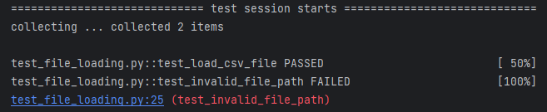
1.2 | Load invalid data from incorrect csv file | 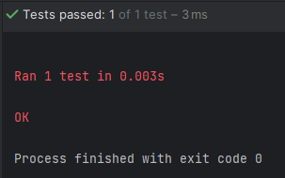  import unittest  import pandas as pd  class TestDateParsing(unittest.TestCase):  def test_valid_load(self):  file_path = 'CrashStatisticsVictoria.csv'  df = pd.read_csv(file_path, parse_dates=['ACCIDENT_DATE'], dayfirst=True)  self.assertIsNotNone(df, "Data should not be None.")  self.assertIsInstance(df, pd.DataFrame, "Data should be a pandas DataFrame.")  self.assertFalse(df.empty, "DataFrame should not be empty.")  self.assertIn ('ACCIDENT_DATE', df.columns, "ACCIDENT_DATE column should exist.")  def test_invalid_load(self):  file_path = 'invalidload.csv'  with self.assertRaises(FileNotFoundError):  df = pd.read_csv(file_path, parse_dates=['ACCIDENT_DATE'], dayfirst=True)  if __name__ == '__main__':  unittest.main()

2.3 | Display a table showing the data from a specific date range - on_search_q1() / update_grid() | 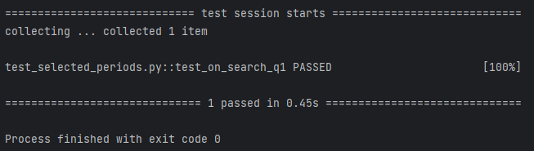  import pandas as pd  import pytest  class TestClass:  def __init__(self):  pass  def m_datePicker_q1_1(self):  return MockDatePicker('2023-01-01')  def m_datePicker_q1_2(self):  return MockDatePicker('2023-02-01')  def m_grid_q1(self):  return MockGrid()  def update_grid(self, grid, data):  grid.ClearGrid()  if grid.GetNumberRows() > 0:  grid.DeleteRows(0, grid.GetNumberRows(), True)  if grid.GetNumberCols() > 0:  grid.DeleteCols(0, grid.GetNumberCols(), True)  grid.AppendCols(data.shape[1])  grid.AppendRows(data.shape[0])  for col, colname in enumerate(data.columns):  grid.SetColLabelValue(col, colname)  grid.SetColSize(col, 120)  for row, value in enumerate(data[colname]):  grid.SetCellValue(row, col, str(value))  grid.AutoSizeColumns(False)  def on_search_q1(self, event, df):  start_date = self.m_datePicker_q1_1().GetValue().FormatISODate()  end_date = self.m_datePicker_q1_2().GetValue().FormatISODate()  start_date = pd.to_datetime(start_date)  end_date = pd.to_datetime(end_date)  mask = (pd.to_datetime(df['ACCIDENT_DATE']) >= start_date) & (pd.to_datetime(df['ACCIDENT_DATE']) <= end_date)  filtered_df = df[mask]  self.update_grid(self.m_grid_q1(), filtered_df)  class MockDatePicker:  def __init__(self, date):  self.date = date  def GetValue(self):  return self  def FormatISODate(self):  return self.date  class MockGrid:  def ClearGrid(self):  pass  def GetNumberRows(self):  return 0  def DeleteRows(self, startRow, numRows, updateLabels):  pass  def GetNumberCols(self):  return 0  def DeleteCols(self, startCol, numCols, updateLabels):  pass  def AppendCols(self, numCols):  pass  def AppendRows(self, numRows):  pass  def SetColLabelValue(self, col, label):  pass  def SetColSize(self, col, size):  pass  def SetCellValue(self, row, col, value):  pass  def AutoSizeColumns(self, enable):  pass  def test_on_search_q1():  test_instance = TestClass()  df = pd.DataFrame({'ACCIDENT_DATE': ['2023-01-15', '2023-01-20', '2023-02-10']})  event = None  test_instance.on_search_q1(event, df)  if __name__ == '__main__':  pytest.main()

3.3 | Display a chart showing average number of accidents per hour - on_search_q2 | import pandas as pd  import matplotlib.pyplot as plt  import wx  import pytest  import math  from matplotlib.backends.backend_wxagg import FigureCanvasWxAgg as FigureCanvas  app = wx.App(False)  class TestClass:  def __init__(self):  pass  def m_datePicker_q2_1(self):  return MockDatePicker('2023-01-01')  def m_datePicker_q2_2(self):  return MockDatePicker('2023-02-01')  def m_panel_q2_graph(self):  return wx.Panel(wx.Frame(None, wx.ID_ANY, "Temp Frame"), wx.ID_ANY)  def on_search_q2(self, event, df):  start_date = self.m_datePicker_q2_1().GetValue().FormatISODate()  end_date = self.m_datePicker_q2_2().GetValue().FormatISODate()  start_date = pd.to_datetime(start_date)  end_date = pd.to_datetime(end_date)  mask = (pd.to_datetime(df['ACCIDENT_DATE']) >= start_date) & (pd.to_datetime(df['ACCIDENT_DATE']) <= end_date)  filtered_df = df[mask].copy()  filtered_df['HOUR'] = pd.to_datetime(filtered_df['ACCIDENT_TIME'], format='%H.%M.%S').dt.hour  avg_accidents_per_hour = filtered_df.groupby('HOUR').size() / filtered_df['ACCIDENT_DATE'].dt.date.nunique()  fig, ax = plt.subplots(figsize=(5, 3))  avg_accidents_per_hour.plot(kind='bar', ax=ax)  ax.set_title('Average Number of Accidents per Hour')  ax.set_xlabel('Hour of the Day')  ax.set_ylabel('Average Number of Accidents')  ax.set_xticks(range(24))  if hasattr(self, 'canvas'):  self.canvas.Destroy()  self.canvas = FigureCanvas(self.m_panel_q2_graph(), -1, fig)  sizer = self.m_panel_q2_graph().GetSizer()  if sizer is not None:  sizer.Add(self.canvas, 1, wx.EXPAND)  self.m_panel_q2_graph().Layout()  class MockDatePicker:  def __init__(self, date):  self.date = date  def GetValue(self):  return self  def FormatISODate(self):  return self.date  def test_on_search_q2():  test_instance = TestClass()  df = pd.DataFrame({  'ACCIDENT_DATE': pd.to_datetime(['2023-01-15', '2023-01-20', '2023-02-10']),  'ACCIDENT_TIME': ['10.30.45', '15.45.30', '09.15.30']  })  event = None  test_instance.on_search_q2(event, df)  if __name__ == '__main__':  pytest.main()  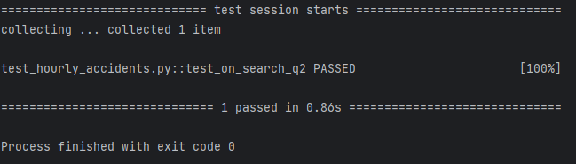

4.3 | Display table of keyword related accidents - on_search_q3 | 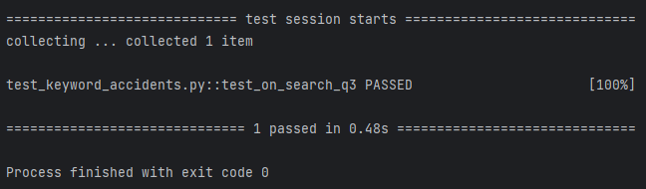  import pandas as pd  import wx  import pytest  app = wx.App(False)  class TestClass:  def __init__(self):  pass  def m_datePicker_q3_1(self):  return MockDatePicker('2023-01-01')  def m_datePicker_q3_2(self):  return MockDatePicker('2023-02-01')  def m_textCtrl_q3(self):  return MockTextCtrl()  def m_grid_q3(self):  return MockGrid()  def on_search_q3(self, event, df):  start_date = self.m_datePicker_q3_1().GetValue().FormatISODate()  end_date = self.m_datePicker_q3_2().GetValue().FormatISODate()  keyword = self.m_textCtrl_q3().GetValue()  mask = (  (df['ACCIDENT_DATE'] >= start_date) &  (df['ACCIDENT_DATE'] <= end_date) &  df['ACCIDENT_TYPE'].str.contains(keyword, case=False, na=False)  )  results = df[mask]  self.update_grid(self.m_grid_q3(), results)  def update_grid(self, grid, data):  grid.ClearGrid()  if grid.GetNumberRows() > 0:  grid.DeleteRows(0, grid.GetNumberRows(), True)  if grid.GetNumberCols() > 0:  grid.DeleteCols(0, grid.GetNumberCols(), True)  grid.AppendCols(data.shape[1])  grid.AppendRows(data.shape[0])  for col, colname in enumerate(data.columns):  grid.SetColLabelValue(col, colname)  grid.SetColSize(col, 120)  for row, value in enumerate(data[colname]):  grid.SetCellValue(row, col, str(value))  grid.AutoSizeColumns(False)  class MockDatePicker:  def __init__(self, date):  self.date = date  def GetValue(self):  return self  def FormatISODate(self):  return self.date  class MockTextCtrl:  def GetValue(self):  return "YourKeyword"  class MockGrid:  def __init__(self):  self.number_of_rows = 0  self.number_of_cols = 0  def ClearGrid(self):  pass  def DeleteRows(self, *args, **kwargs):  pass  def DeleteCols(self, *args, **kwargs):  pass  def AppendCols(self, *args, **kwargs):  pass  def AppendRows(self, *args, **kwargs):  pass  def SetColLabelValue(self, *args, **kwargs):  pass  def SetColSize(self, *args, **kwargs):  pass  def SetCellValue(self, *args, **kwargs):  pass  def AutoSizeColumns(self, *args, **kwargs):  pass  def GetNumberRows(self):  return self.number_of_rows  def GetNumberCols(self):  return self.number_of_cols  def test_on_search_q3():  test_instance = TestClass()  df = pd.DataFrame({  'ACCIDENT_DATE': pd.to_datetime(['2023-01-15', '2023-01-20', '2023-02-10']),  'ACCIDENT_TYPE': ['Collision', 'Rollover', 'Collision']  })  event = None  test_instance.on_search_q3(event, df)  if __name__ == '__main__':  pytest.main()

6.3 | Display charts of speed related incidents – on_search_q5 / generate_graph_q5 / generate_injury_graph | 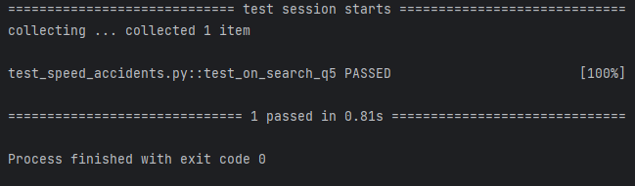  import pytest  import pandas as pd  import matplotlib.pyplot as plt  import wx  from matplotlib.backends.backend_wxagg import FigureCanvasWxAgg as FigureCanvas  class TestClassMock:  def __init__(self, parent):  self.m_choice1 = wx.Choice(parent, wx.ID_ANY)  self.frame = parent  def on_search_q5(self, event):  global mask  selected_speed = self.m_choice1.GetString(self.m_choice1.GetSelection())  df = pd.DataFrame({  'SPEED_ZONE': ['40 km/hr', '50 km/hr', '60 km/hr', '70 km/hr', '80 km/hr', '90 km/hr', '100 km/hr',  '110 km/hr'],  'ACCIDENT_DATE': pd.to_datetime(['2023-01-15', '2023-01-20', '2023-02-10', '2023-03-15', '2023-04-20', '2023-05-10', '2023-06-15', '2023-07-20'])  })  df['SPEED_ZONE'] = df['SPEED_ZONE'].astype(str)  if '40 Km/h' in selected_speed:  mask = (df['SPEED_ZONE'] == '40 km/hr')  elif '50 Km/h' in selected_speed:  mask = (df['SPEED_ZONE'] == '50 km/hr')  elif '60 Km/h' in selected_speed:  mask = (df['SPEED_ZONE'] == '60 km/hr')  elif '70 Km/h' in selected_speed:  mask = (df['SPEED_ZONE'] == '70 km/hr')  elif '80 Km/h' in selected_speed:  mask = (df['SPEED_ZONE'] == '80 km/hr')  elif '90 Km/h' in selected_speed:  mask = (df['SPEED_ZONE'] == '90 km/hr')  elif '100 Km/h' in selected_speed:  mask = (df['SPEED_ZONE'] == '100 km/hr')  elif '110 Km/h' in selected_speed:  mask = (df['SPEED_ZONE'] == '110 km/hr')  filtered_data = df[mask]  speeding_counts = filtered_data.groupby('ACCIDENT_DATE').size().reset_index(name='ACCIDENT_COUNT')  speeding_counts['DAY_OF_WEEK'] = pd.to_datetime(speeding_counts['ACCIDENT_DATE']).dt.day_name()  self.generate_graph_q5(speeding_counts)  def generate_graph_q5(self, data):  panel_width, panel_height = self.frame.GetSize()  fig_width, fig_height = panel_width / 100, panel_height / 100  accidents_by_day = data.groupby('DAY_OF_WEEK').agg({'ACCIDENT_COUNT': 'sum'}).reset_index()  order_of_days = ['Monday', 'Tuesday', 'Wednesday', 'Thursday', 'Friday', 'Saturday', 'Sunday']  accidents_by_day['DAY_OF_WEEK'] = pd.Categorical(accidents_by_day['DAY_OF_WEEK'], categories=order_of_days,  ordered=True)  accidents_by_day = accidents_by_day.sort_values('DAY_OF_WEEK')  fig, ax = plt.subplots(figsize=(fig_width, fig_height))  ax.bar(accidents_by_day['DAY_OF_WEEK'], accidents_by_day['ACCIDENT_COUNT'], label='Number of Accidents',  color=['blue', 'orange', 'yellow', 'green', 'pink', 'blue', 'purple'])  ax.set_title('Total Speed Related Accidents Per Day of Week')  ax.set_xlabel('Day of the Week', fontsize=8)  ax.set_ylabel('Number of Accidents', fontsize=8)  ax.tick_params(axis='x', rotation=45, labelsize=7)  if hasattr(self, 'canvas_q5_1'):  self.canvas_q5_1.Destroy()  self.canvas_q5_1 = FigureCanvas(self.frame, -1, fig)  def test_on_search_q5():  app = wx.App(False)  frame = wx.Frame(None, wx.ID_ANY)  test_instance = TestClassMock(frame)  test_instance.m_choice1.AppendItems(  ['40 Km/h', '50 Km/h', '60 Km/h', '70 Km/h', '80 Km/h', '90 Km/h', '100 Km/h', '110 Km/h'])

Further Test Code for GUI
1.1 | Full loading Application Test | 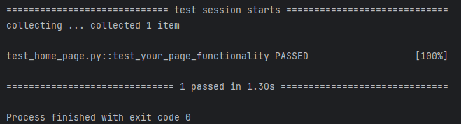  import wx  import pytest  from accident_analyzer import Frame  @pytest.fixture  def wx_app_and_frame():  app = wx.App(False)  frame = wx.Frame(None, wx.ID_ANY)  return app, frame  def test_page_functionality(wx_app_and_frame):  app, frame = wx_app_and_frame  page_instance = Frame(frame)  frame.Destroy()

Coverage Report
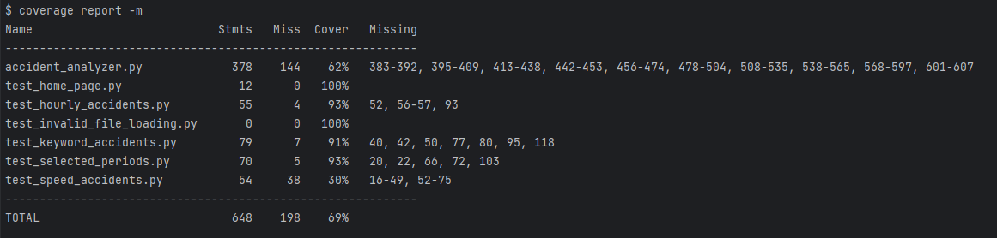
Figure 1: Coverage Report
The coverage report shows how much of the code is run during the testing process:
- Function Coverage
The Function Coverage metrics focus on ensuring that each of the functions within the code are executed at least once during the testing process. Although not 100% coverage the application itself and functions all work flawless as designed. Understanding why these are 100% coverage could allow for more efficient code to be produced.
- Statement Coverage
Is about making sure that individual lines or statements within the code are being executed. Most of the files have high coverages besides test_speed_accidents however this does not affect its functionality. This means a small portion of the code is being tested.
- Branch Coverage
The reason some of the coverage files have a lower percentage is due to some branches within the files not properly being tested. Such as if and else statements not being properly noted. Examples being making sure a True and False conditions are always both met.
- Condition Coverage
Condition Coverage represents ‘AND’ and ‘OR’ or True and False statements. accident_analyzer contains missed lines leading to the inadequacies. It is always very important to cater to all Boolean expressions and possible outcomes. However the code still functions without issues but its safe practice to implement fully developed case scenarios.

Requirements Acceptance Testing

Software  Requirement No | Test | Implemented (Full /Partial/ None) | Test Results (Pass/ Fail) | Comments (for partial implementation or failed test results)
1.1 | The system shall provide a user-friendly interface for easy navigation and interaction. | Full | Pass | This software requirement function as required
1.2 | The system shall enable users to select specific date ranges for data retrieval. | Full | Pass | This software requirement function as required
1.3 | The system shall display accident details for user-selected periods. | Full | Pass | This software requirement function as required
1.4 | The system shall produce an hourly chart showcasing the average number of accidents for chosen periods. | Full | Pass | This software requirement function as required
1.5 | The system shall allow users to input keywords and filter accident types accordingly. | Full | Pass | This software requirement function as required
1.6 | The system shall offer dedicated analysis tools focusing on alcohol-related accidents. | Full | Pass | This software requirement function as required
1.7 | The software shall provide an "insight tool" to automatically generate notable patterns or trends from the dataset. | Full | Pass | This software requirement function as required
1.8 | The system shall ensure data privacy and prevent unauthorized access. | None | Fail | The system didn’t allow for users to have data privacy or prevent unauthorised access. This would need to be implemented to meet this requirement
1.9 | The system shall support data input in different formats like CSV, Excel, and JSON for flexibility in data sourcing. | Partial | Pass | The system was capable of reading CSV but wasn’t rested with other data formats.
1.10 | The software shall be compatible with various operating systems (e.g., Windows, macOS) to ensure broad user accessibility. | Partial | Pass | The software worked with current Windows and Mac operating systems but wasn’t tested on a full array of operating systems.
1.11 | The system shall provide error messages in case of invalid date ranges or keyword inputs. | None | Fail | No error messages are prompted when an incorrect user selection is made.
1.12 | The system shall ensure that the data presented is updated and synced with the original dataset at regular intervals. | Partial | Pass | The information is retrieved every time the application is used. This means it only refreshes once the software is relaunched.
1.13 | The system shall be optimized for performance to handle large datasets without lag. | Full | Pass | This software requirement function as required

